Feb 18 – Screen shots

Boot Key for your manufacturer

Dell- F2 or F12

Clean install: two versions:

1. Retain old Windows install

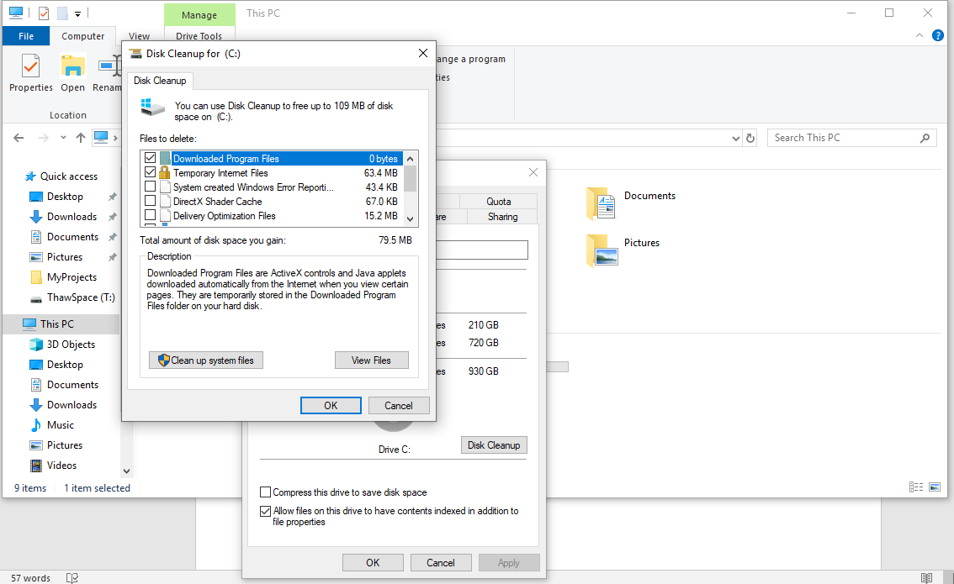

Remote connections – protocol

Ports

HTTP 80

HTTPS 443

RDP Port ????

Dir f:\\*.xlsx /s

Search through subfolders

Windows.old

WSL Windows Subsystem for Linux

ISO

EULA- End User License Agreement

mmc- Microsoft Management Control

File Explorer will mount

ZIP

Bootable Device – DVD, CD,

USB

F8 Windows Safe Mode

